https://youtu.be/Gm6WGZAfPNA

Creating a drop-down selection in WordPress

Step 1: open your WordPress with this extension…
https://cassiecqu.wordpress.com/wp-admin
Once here you are in the dash board.
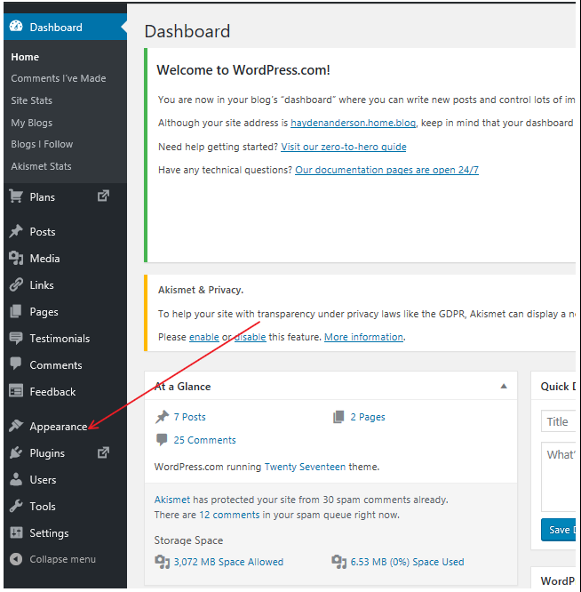
Click on the appearance tab:

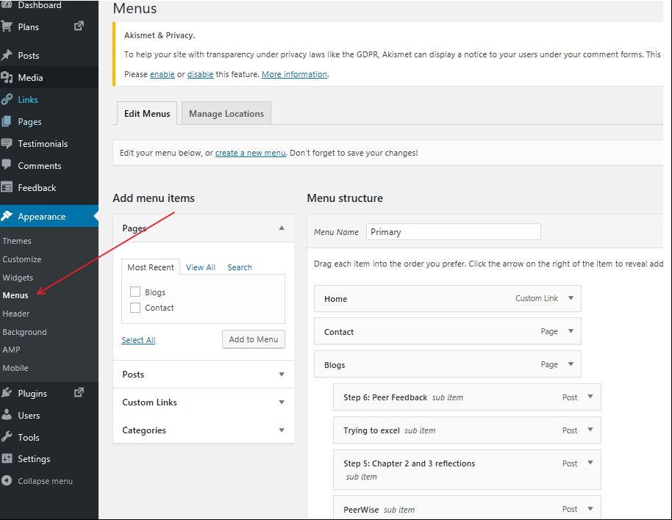
Then click on the Menus Tab:

Once in the menu tab you can select the “POSTS” drop down.
The idea is to add these to the Menu by clicking each post.
Doing this will place the on your menu structure as per below.
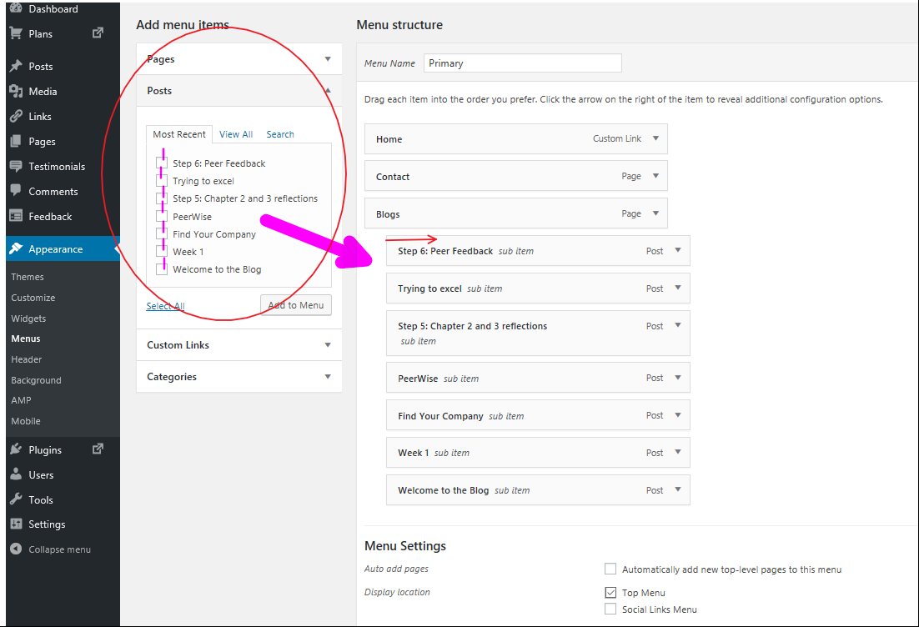
From here you can re-arrange them by dragging them in order underneath the “Blogs” tab.
You then need to move then slightly right so they become a sub item to your “blogs”.
Its also important to remember you must do this every time you post etc. As I am unsure how you get them to this position with each new post.
I’ve attached a video link to the document to help.
Good Luck.
Hayden.

