ACCT11059 Accounting, Learning & Online Communication
  - ASS#1
Hayden Anderson | S0090574 |CQUniversity

Step 3: Find Your Company

AIA – Auckland International Airport
I think you could be forgiven for assuming that an airport wouldn’t be a publicly listed company, in fact I often never gave it much thought until I started being more involved with purchasing shares and managing how my superannuation was invested. Moreover, many people including myself often would think of an airport as a government owned infrastructure much like roads. I’m interested to see the relationship between the New Zealand government and AIA in this assessment.
Martin has the company listed under the guise of airports and infrastructure and undoubtedly it is, however reading the company bio its surprising to see that AIA lists itself not only as an infrastructure player but also a service provider providing “a world-class business park, commercial office buildings, transport and logistics warehouses, hotels and leisure and recreation facilities”.
Diversification is an important part in the business world and airports have seen rapid change over the last 50 years especially as they reach into international and business markets. It appears from the outset that the AIA has set out on some large-scale capital developments over the last few years. In fact, reading the FY18 annual report the first two pages peel the lid back on AIA’s planning from FY18 through to FY28.
Delivering, Planning and Building are the three key markers used in the graphic and this sets the foundation to the message AIA is pushing in their report. It seems AIA has delivered on more international aircraft gates across FY17/18 an airfield expansion and even a Bunnings distribution center. Further airfield expansions are set for 2022 with a second runway set for 2028. This would appear to be in-line with the rapid growth NZ has seen in its tourism sector over the last 5 years as reviewed on the Tourism Industry Aotearoa’s website.
- Total annual tourism expenditure is $39.1 billion - $107 million per day.
- Annual international tourism expenditure is $16.2 billion – $44 million per day.
- Annual domestic tourism expenditure is $23.0 billion – $63 million per day.
- Total annual tourism expenditure has increased by $11.9 billion or 44% in the past five years.
- Tourism is our biggest export industry, contributing 21% of foreign exchange earnings.
- Tourism generates a direct annual contribution to GDP of $15.9 billion, or 6.1%, and a further indirect contribution of $11.1 billion, another 4.3%.
- 216,000 people are directly and another 149,000 indirectly employed in tourism in New Zealand – almost 1 in 7 jobs.
- The annual GST paid by tourists is $3.7 billion, including $1.7 billion collected from international visitors.
Source: https://tia.org.nz/about-the-industry/quick-facts-and-figures/
Reading through the opening lines of the report from AIA gets me thinking about value. Study guide chapter one discussed how business is about creating value. It appears AIA has seized the opportunity to piggy back off the tourism demand and create significant value to serve demand and need. There is also substantial interaction within markets in their business plan. The fact they are an airport displays their interaction with various markets from the airlines that are using their infrastructure to deliver their own service through to the hotels restaurants and shops that have set up businesses within the AIA percent. Just thinking about it holistically all three markets (input, product and capital markets) appear to be receiving interaction with AIA.
Interestingly, the annual report opens up discussing how AIA has recently sold their stake in North Queensland Airports for a whopping $A370 million. I decided to do a little research into this and it appears this was a capital grab in order to help facilitate the major CAPEX projects planned for AIA into the next 5 years which were estimated at $1.8 billion whilst reducing some of AIA’s debt. After the NQA had had significant turnaround in earnings after a weak FY16 it appears AIA were keen to strike while the iron was hot and leverage the turnaround for their own developments. As seen below it appears the sale of stake in NQA has related to an upward trend in AIA value over the year.
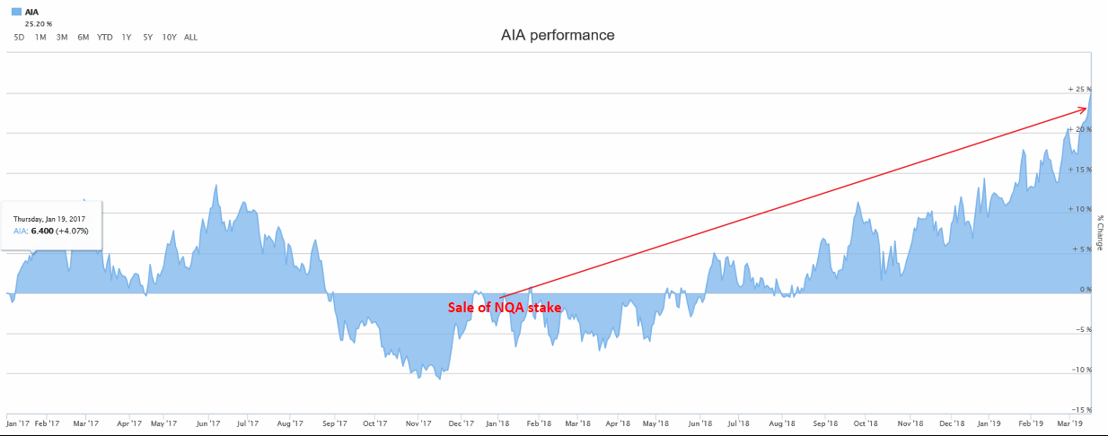
Source: https://www.asx.com.au/asx/share-price-research/company/AIA

Another fascinating point in some of the opening monologue is that Chinese arrivals into AIA growth was around 10.9%. Doing some reading recently on the impact of the Chinese markets across Australia I decided to look into the Chinese economy and if the reports on it “cooling” would bring impact to a company like AIA especially noting one of AIA’s key aspirations is to “double Chinese arrivals to 400k” in FY17. The Yuan has been reasonably steady in relation to the NZD over the last year, hovering around 0.22c on the dollar with only mild fluctuations. There have been many analytical reports that the outlook across the Chinese market has been glim, however it would appear this may affect industries such as manufacturing and trade rather than tourism such as NZ.
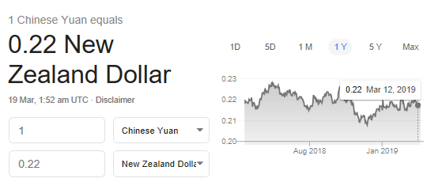

Source: google
So, what about the numbers?
FY18 results looked pretty good for AIA. Total profit after tax to 30 June 2018 was up 95.3% to $650.1 million, while underlying profit after tax increased 6.2% to $263.1 million. 95.3% increase in profit seems very dramatic from the outside looking in. Revenue saw an 8.7% increase to $683.9 million which the company attributes to “strong growth in retail, transport and investment property revenues. The AIA report details a 13.6% increase in operating expenses due to operational resources and asset management. EBITDAFI sits at $506.4 million up 7%. Interestingly I have only ever been exposed to EBITDA a first for the fair value adjustments and investments in associates part of the acronym for me.
One of the key areas I have struggled to comprehend within this report is a statement pertaining to derivate fair value movements.
“We have reversed out the impact of derivative fair value movements. These are unrealised and relate to basis swaps that do not qualify for hedge accounting as well as the ineffective valuation movement in other derivatives. The group holds its derivatives to maturity, so any fair value movements are expected to reverse out over their remaining lives”
I have absolutely no idea what this means. A quick google search brings up topics on hedge accounting and buying stock. Perhaps this is something that will become clearer throughout this unit? Within the notes section of the financial report it states, “the group held interest rate swaps and cross-currency interest rate swaps where it receives a fixed rate of interest and pays a variable rate on the notional amount.” This is why these are stated as liabilities within the statement due to their ability to denote future value.
Working through the financials some more and inputting these into our company spreadsheet I found some terminology I believe is valuable to understand a little further. The first is “Deferred tax liability”. Section 7c of the report breaks these down. It appears this is a tax that is due in the future but is yet to be paid.
Next is “Provisions” which are stated within the notes as “an obligation to fund the acoustic treatment of homes and schools within defined areas when noise exceeds certain thresholds and when the offer of acoustic treatment is accepted. On acceptance of offers, the group records a provision for the estimated cost of fulfilling the obligation.” Again, future value decreases due to the entity’s obligations which are yet to be paid.
Within the EBITDA section “Derivative fair value decrease” is listed. This is explained under the same notes area as derivate fair value movements. So, I am slightly confused, perhaps this is because sometimes the cash and hedge derivatives make a loss but sometimes they make a gain.
The final item that confused me was “Fair value gains/(losses) recognised in the cash flow hedge reserve”. This is listed under items that may be reclassified subsequently to the income statement. Defined within the notes as “The cash flow hedge reserve records the effective portion of the fair value of interest rate swaps that are designated as cash flow hedges. Amounts transferred to the income statement are included in interest expense and other finance costs.” So, a liability for future gains or losses against. A quick google search details a Cash Flow Hedge is used when an entity is looking to eliminate or reduce the exposure that arises from changes in the cash flows of a financial asset or liability (or other eligible exposure) due to changes in a particular risk, such as interest rate risk on a floating rate debt instrument.
Derivative financial instruments are explained as, “a contract that derives its value from the performance of an underlying entity. This underlying entity can be an asset, index, or interest rate, and is often simply called the "underlying."” I’m wondering how and why AIA has this listed under this title.
I’m looking forward to inputting the financial numbers of AIA into the spreadsheet provided by Martin. I like to think of myself as reasonably handy with excel so perhaps some pivot tables can be developed across the three years’ worth of data to establish some trend analysis and extrapolate onto some graphs.
From the outset it appears AIA is a reasonably solid company with a very diversified business and investment structure. Positive results across the FY18 report indicate the company is in a reasonably strong position with regard to financials and there is a streamlined vision for infrastructure development across the next 5 years. It seems their plan for growth across the Asian and Chinese markets are statistically in-line with the tourism figures and New Zealand and Australasia.

Reports
2018 Annual Report
2017 Annual Report
2016 Annual Report
2015 Annual report
2018-2017 Financials
2016-2015 Financials

Blog link
Hayden Anderson - CQUniversity

Step 4: AIA Financial Spreadsheet


Step 5: Chapter 2 and 3 reflections

Chapter 2
Rules and regulations…I feel my stomach sinking as I read that as I can only begin to imagine the amount of regulatory red tape involved in business accounting. It may be one of the most off-putting things about the financial sector for myself. However, its undeniable that the more intimately you know the regulations behind these types of “games” the better placed you are to play them.
Interestingly as I have been more engaged with my own financial situation, that is superannuation and the share market I have become increasingly aware of the importance in placing money with companies deemed “stable”. I guess one of the major flaws with this process is how one determines what is and isn’t stable. There is a plethora of information now available on listed companies as discussed in section 2.1, however the interpretation of the data is what is key to making sound decisions.
When reading about the legal requirements and accounting standards enforced by the AASB I began to think about how many small business owners “keep” their own books, and to what sort of standard they do this? I know we discussed this at length in the opening sections and in section 2.1 it explains there isn’t a requirement for small business to comply to these standards, however it got me thinking about how technology would have helped many of these small businesses as it has progressed. Undoubtedly many people probably have their bookkeeping done by a professional accountant, however it is food for thought.
You can’t have a rule for everything. This is a fascinating statement not just in relation to accounting but in general life. The reading discusses how the world is made up of “shades of grey” and how the development of personal meaning and learned behaviors builds real knowledge. I have found this out for myself over time, especially in my working career. During my time in the Royal Australian Navy this was one of the most poignant experiences I found. It was especially real for me as I joined the Navy at 24 years of age. Now 24 isn’t especially old, however when you are surrounded by kids fresh out of school the differences in learned experience are stark. It was also evident because many of my superiors were actually older than me and had joined the Navy fresh out of school. The defence force can be its our incubator, many people who serve in the military join from school age and have never experienced working in “the real world”. They build a knowledge base surrounded by people of the same ilk, this in itself breeds a world of “black and white” and a significant misunderstanding of the principle that there are in fact many shades of grey to life.
Accrual accounting isn’t a new concept in its representation even if the terminology is. I liked the reference Martin has used to electricity companies, in fact I experience this in my daily running of my own business. However, it got me thinking if the process also includes the swapping of services for goods. I know for example within my company rebates are common practice especially when brining on new clients. My company may offer a discount on pricing for a return service or may offer to incorporate printing setup costs in the sell price of goods instead of a company having to pay up front costs.
Quality of information is concept that touched a nerve with me during the readings. Recently I have been having robust conversations about this within my own company. I recently mentioned this in a meeting when a technical engineer was talking to some key stakeholders about a productivity sheet he had developed. The problem with the sheet was that he had developed it based of data he had pulled from thin air. I mentioned to him that his figures were wrong because the quality of information is only as good as the data you put in. You see, he had failed to take real time measurements of these productivity figures from my machinery, he was only using the data represented from the manufacture of the machinery. This data didn’t consider things such as downtime, human error and a variety of other information that would skew the results. Much like relevance and faithful representation the data wasn’t a representation on the actual figures experienced locally and as such its relevance was diminished.
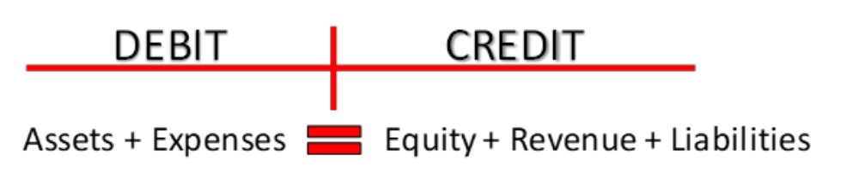
So, I thought this would be a good point to reflect on some of the key concepts so far and try and explain them back to myself in this stage of the assessment. I began by making myself a small graphic to remind myself about double entry accounting and the accounting formula.

Martin has discussed the five key accounting principles. Of course, they are heavily intertwined to each other in an almost symbiotic relationship. One of the things that stood out and has been re-enforced is that dividends paid out or shares brought are not related to expenses or revenue which was initially a bit of a head scratcher.
Assets have been defined as prospective future benefits to the company. That is items owned that will provide that add value. From the outside this seems relatively straight forward although got me thinking about my own business and stock within it. After 12 months stock within my business becomes classified as “aged stock” and gets de-valued. So, can stock also be a liability?
Liabilities are economic obligations that take away value from our business in the future. I am currently having a packaging machine built by a company in Spain for my business. So, the cost of this is a liability but once paid the machine is an asset. However, after the maintenance warranty expires on it its upkeep would become a liability.
Equity is the value of interest of owners in a business i.e. assets-liabilities. You often hear people say I have equity in that business. Equity seems like that leftovers after all the operational P&L is complete. However, I have a feeling Equity may be a little more complex than that.
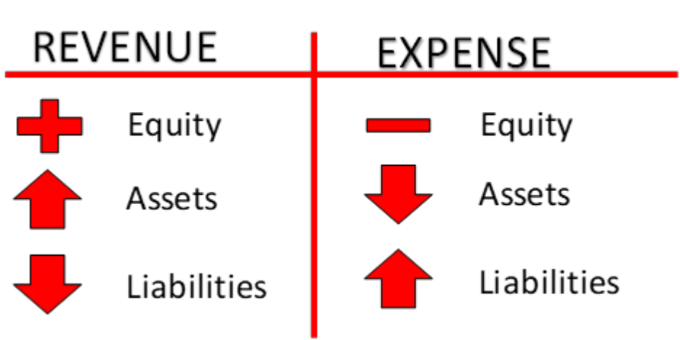
Revenue and Expense are the reactions to each other. That’ is best explained in the graphic I made below.

These are described as “temporary” accounts, that is to say they are accounts tracked monthly etc. and reset each financial year. They directly attribute to the change in value of the company.
Like with most of my learning I would love to input multiple items into P&L accounts and look at these 5 elements of accounting and how they are affected. I’m assuming this is the goal for our company so that we have a real-world example to reference. I wonder how many people will be interested in becoming shareholders of their companies after the have done a deep dive into their financial records.

Chapter 3
A firm’s balance sheet shows its financial position on one day – this is the main information I took away from the opening section of chapter three. I don’t think I was surprised by this as I would assume this is based on its reporting method as per financial years for tax etc. I figure it would be balanced on this “one day” because this would be the day that the revenue and expenses are reset for the next financial year.
The footnotes break down the balance sheet in depth in-order to allow the information consolidated in the balance sheet to be much more presentable and in a format that is easier to read. This allows equity holders or prospective investors a simplified snapshot of the company’s financials over a particular period. I find the act that various companies have a different way of presenting “the facts” of their financials very intriguing. I wonder how much of this is to allow them to hide particular information amongst other data sets. Maybe that’s just the sceptic in me?
One of the major things I found it hard to get my head around is the consolidated statement of comprehensive income. In particular items such as “fair value movement” or as described within my sheet “Fair value gains/(losses) recognised in the cash flow hedge reserve.” As previously discussed I attempted to break this down within the notes section and within a quick google search. The cash flow hedge reserve records the effective portion of the fair value of interest rate swaps that are designated as cash flow hedges. Amounts transferred to the income statement are included in interest expense and other finance costs.” So, a liability for future gains or losses against. A quick google search details a Cash Flow Hedge is used when an entity is looking to “eliminate or reduce the exposure that arises from changes in the cash flows of a financial asset or liability (or other eligible exposure) due to changes in a particular risk, such as interest rate risk on a floating rate debt instrument.”
To be honest there was a lot to dissect here and I don’t believe I have fully grasped what is really going on. I’d be interested to discuss this further with someone who is well versed across something like this. I sort of understand the idea of risk reduction around assets, but I don’t fully understand how that is achieved through a “cash flow hedge”.
SOCIE may be the easiest table to understand, I’m not sure if this is because it is broken down into segments that read mush easier or because the terminology within the table seems much more simplified. The SOCIE table is the source of truth for comprehensive income loss and profit.
I genuinely didn’t realize that running out of cash was the only way to go into liquidation but on reflection is pretty obvious. This idea is profound and relative to myself currently as my parents have recently had an experience where a company they were dealing with experienced this. I guess it makes sense and is why liquidators take over other assets in order to re-coup any cash they can to pay off outstanding debts. We didn’t have to details the statements of cash flow in our spreadsheets for assignment 1, I believe this is something we touch on in assignment 2.
Structures and Rations are discussed with relation to analysis of a company’s financials and it appears the jury is still out of how successful these can be. The idea of 2:1 or basically having more assets than liabilities and the ability to access cash be it through loans or cashflow through your business is a reasonable schematic for success. It got me thinking about a formula to success. It may be a reason why so many people have differing opinions about how and where to invest. It may also be a reason why many economist or people within the financial world are oblivious to market crashes. The other concern is how much a company can manipulate their financials in order to deceive equity investors. I read a story today about a company called Theranos who basically lied to equity investors about the company’s financials and their products alike. Its scary to think that a listed company can deceive through manipulation of their financials, but even scarier to think that people investing significant capital don’t have the ability to decipherer to actuals vs the lies within these results.
I loved that Martin references Warren Buffet so much. I recently watched a documentary of his and several things struck me. Firstly, how controlled and measured he is along with his amazing intelligence with regards to financials. Secondly, the amount of companies Berkshire Hathaway Inc own. And thirdly, the recipe he developed for investing in what he called cigar companies. If you get the time its well worth the watch.
Equity value = PV (present value) of expected future dividends this is the theoretical formula for equity entitlement of a business for investors. I guess if you can “guestimate” growth in dividends you can forecast capital growth. This is “the game” of share market investing. In reality its calculated gambling using the discounted dividend model. The only certainty is there are going to be various changes to a business that affect this outcome. Martin discusses how a company can decide to increase its dividend payout ratio. Furthermore, a company could have a disastrous marketing outcome much like Nike did recently with a college basketballer who was wearing their shoes. The player who was rated the top draft prospect for the NBA had a “shoe explosion” and was injured. This sub sequentially led to Nikes share value plummeting by $1.1bn. No one could have seen this coming and it demonstrates perfectly the difficulty in valuing company equity. There are many factors at play here not just future dividend policy or management.
It’s been 18 years since I did grade 10 math…we’re really getting into the formulas now;
Dividends (d) = Operating cash flow (C) – Capital outlays (I) + Net cash flow from debt owners (F)
that is, d = C – I + F.
Cash flow is the liquidity of cash through selling products gross, where as Capital outlays are the cash invested back into the business in order to assist in the selling of those products. Together these equal the FCF or free cash flow.
So, martin explains that:
“As FCF = C – I, we could change our relationship of dividends and cash flow from:
d = C – I + F
to:
d = FCF + F”
The head scratching has begun… I’m looking forward to digging into some real-world examples of these in-order to better understand.

Step 6: Peer Feedback
When deciding who and how to give feedback to I rested on the following three items.
- Give feedback to one person who inspired me to write a better assignment.
- Give feedback to one person I felt was just starting out at Uni (post year 12).
- Give feedback to a random person – someone who I hadn’t engaged with regularly or followed their blog.
The following is the result:

The inspiration
The Balance - Chris from Brisbane, mature aged student. I started following Chris in the first week. His Blog is sharp, and his writings are in-depth. His feedback is listed below.
Step 1  KCQs | Chris’s blog is well written and easy to read. He conveys meaning in his writings and you can tell he has actually absorbed what he has written. From the outside looking in I would assume Chris is already highly educated or at least a professional in some context. I guess I was drawn to Chris’s blog initially because it looks great but as I read further I could see some of myself in his writings. Chris’s KCQs in Chapter 1 are very self-reflective much like mine were. I have a feeling he will refine this down as he progresses through the unit and receive critique from Martin.  Overall and extremely solid start.
Step 2  Moodle & Blog | What can I say about Chris’s blog…  From the outset it is sharp! That is, it really catches the eye – you can tell he is rather tech savvy, he initially posted about using Gannt Charts which drew me in as I am a project manager, and this is one of the tools we often use to track projects.  His writings are well written and spaced out which makes them easy to read. I have enjoyed following his blog from the start and it goes to show that presentation can be an important factor in a modern world.
Step 3  Background info and KCQs on Company | Chris initially commented on my post about my company prior to posting about his. He stated that my post was so “in-depth” it was almost like a mini annual report. When it came time to read his I almost felt ashamed I hadn’t put as much effort in as he did. I’d like to think I inspired him to push all his chips in on his post, and undoubtably he did. His Step 3 is well thought out and in-depth. Chris has great links to relevant information about his company including ASX related graphs and investor background. Chris’s KCQs are the best I have read so far – he links the relevant information he found back to important key topics discussed in the readings which show he has really learnt the content.  After reading his company report it made me go back and work a bit more on mine. I think the reflection has helped me write a better set of KCQs. It appears the process of feedback is working well.
Step 4  Spreadsheet | Chris’s spreadsheet is pretty straight forward. I think it could value add to have some underlining of totals columns to allow the eye to focus into key areas. Chris has done a solid job at highlighted discrepancies in red and adding notes where he was unsure of values.  It would also add some value to input hyperlinks into his financial statements in the documentation area. This allows readers to quickly look up the referenced data.  Overall a solid start.
Step 5  Chp. 2-3 KCQs | As of 1/4/19 Chris’s Step 5 was not available.
Step 6  Individual Feedback | Looking through Chris’s blog and being followed by Chris I have come to find that he does provide significant feedback on many posts. One thing I have noticed is that he has a lot of comments on his posts which enables him to engage with people quite regularly. Overall, I believe it’s the quality of his blog that draws people to it, this in turn has enabled Chris to interact with people about his and their content.
Step 7  Overall ASS#1 | Overall Chris’s assignment is very solid. He has provided a great deal of insight into Ausdrill and his KCQs are some of the best I have read.  8.5/10

just starting out
Journey through Accounting – Kayla. First year university student fresh out of year 12. Kayla gives great comments on my blog posts and was one of the first people to follow me. Her feedback is below.
Step 1  KCQs | I really love the way Kayla writes about herself, I can almost feel her personality popping off the pages. From the outset I can tell Kayla is much younger than me. This is not a negative thing, but she really conveys her youth and enthusiasm through her words and even the fact her headings are in purple displays her enthusiasm. Kayla’s KCQs are very self-reflective which is great because I believe this is a fantastic way to think about stuff you are learning. Kayla is able to write KCQs that are very relative to the items she has just learnt. I’m actually impressed with her articulation considering she has only just finished year 12. Thinking back to how I wrote in 2002 when I was in year 12 I think I would have been put to shame. If I could pick on one thing on Kayla’s document, it would be the font she has used. I know there is no set format in the unit, but I believe a better use of font would make her document easier to read.  Overall a great start to Kayla’s journey.
Step 2  Moodle & Blog | Kayla was one of the first Blogs I followed which meant she was very organized prior to the unit starting. Her Blog is a crisp white background and very simple to follow. She regularly comments and gives feedback to a range of users which is great. I think she could add a little bit more media into it rather than just photos however I like the fact she posts personal photos of her life it makes the reader feel more attached. Perhaps the odd video on a relative topic would help but overall, it’s a crisp and clean setting.
Step 3  Background info and KCQs on Company | Kayla has done a great job of reporting on her company “Vocus Group”. She has provided a great breakdown of the company’s financials as well as links to relevant media she can across. Her Step 3 is well laid out and the KCQs are thoughtful. She has been able to find information she was unsure of and rectify this after reading various chapters of the study guide. You can see how she has worked through this process within her understanding of the EBITDA acronym which she references. I like hos Kayla has broken her company into subheadings, this allows the reading to focus in on the key points Kayla is trying to construct.  Overall, a very good step 3.
Step 4  Spreadsheet | The Vocus Group spreadsheet Kayla has put together is very solid. She has done a great job with her formatting especially within the heading sections. Kayla could improve by tidying up some of her totals columns. There are a few that have been underlined, however some have been left off. She could also value add by inserting links to her company’s financials in the documents section. Apart from this it’s a great start.
Step 5  Chp. 2-3 KCQs | Kayla’s Step 5 is lacking a little, I think she could have added some more data into this area. Although, she has done some great reflecting here and been able to ask some questions of information she didn’t quite comprehend. She has done a good job on reflecting back on her own company.
Step 6  Individual Feedback | I think Kayla has the best interaction that I have seen. This may only be matched by Paul Feasey whom is another blog I follow closely. Kayla’s feedback can sometimes be generic in nature and be more about how she liked the quality of someone’s posts. I haven’t seen Kayla give too much constructive input into how people can improve or enhance their assignments, however her positive re-enforcement of their work shines through.  Overall, Kayla’s feedback is well thought out and engaging.
Step 7  Overall ASS#1 | I have enjoyed the vary degrees of people content as I have followed their blogs. Kayla’s assignment stands out to me due to the enthusiasm she writes with. I believe she has attempted to improve where she has received feedback which displays her willingness to get better throughout the process. Overall a great first effort from Kayla.  7.5/10

the random
Shall I put that on your account? – Emma. A first-year student but is also working full-time. Emma was the first person to comment on my draft work so was an easy choice as she was someone I didn’t previously follow but now do.
Step 1  KCQs | Emma does a great job at introducing her self and setting the scene of her background. This enables the reader to engage with her on a personal level. I felt Emma’s Step 1 was lacking some KCQs regarding the actual subject matter however this is probably a common thing for most people as they try to figure out how to actually structure such things. I’m looking forward to delving into her future Steps.
Step 2  Moodle & Blog | Emma’s Blog is simple and neat. From the outset I noticed her blogs can be hard to differentiate between as they aren’t separated by distinct headings or pictures. I think this may be her first time blogging which is understandable. Emma is also working full-time and doing two units, so I don’t envy her workload. Things like blog presentation take a back seat when you are juggling so much. Overall, a sound foundation.
Step 3  Background info and KCQs on Company | I came across Emma after she initially commented on my Moodle post for this step. In-turn I decided to read her Step 3.  Emma’s Step 3 is in-depth and well written. I believe it would value add if she did the following:  -Provide references to any topics she has discussed - perhaps news article links etc. about their community programs like paws up.  - give actual figures and % for financials e.g.: "drop in financials" what percentage?  Emma did a great job with simplifying cases through "relatable examples" and overall this is a solid Step 3.
Step 4  Spreadsheet | As of 1/4/19 Emma’s Step 4 was not available.
Step 5  Chp. 2-3 KCQs | As of 1/4/19 Emma’s Step 5 was not available.
Step 6  Individual Feedback | There were no comments on Emma’s blog at the time of writing this. Emma did however comment on my Moodle post which enabled me to interact with her in the first place. If emma was to have the comments enabled on her blog she may find her feedback value goes up.
Step 7  Overall ASS#1 | Due to the fact significant sections of this assessment were not available at the time of writing this I feel I shouldn’t be too critical here. Doing the marking off Step 3 I believe Emma could value add by inserting a little more media and relevant data into the step. Her blog could improve through some YouTube videos or pictures and changing the font to enable the reading to interact a little easier.  Overall 5.5/10.

