ACCT11059 Accounting, Learning & Online Communication
  - ASS#2
Hayden Anderson | S0090574 |CQUniversity

Step 2: Chapter 6 Reflection

Cost Objects
The idea of association cost to various objects is a familiar process to me. Within my business we attribute various costs to “cost center’s” this enables us to breakdown various functions of cost within the business and better understand the overall P&L landscape. This in-turn allows us to paint a clear picture of the “real costs” and the work out our sell price to ensure we have enough GM built into the price.
The other concept of associated costs to goods produced but not sold in a particular period is of intertest to. This is a common theme across wholesale business especially ones that carry goods for an extended period. Having these marry up accurately can be hard especially with overlapping production months. My business also often de-value stock after an aging period and perhaps this is something to do with the “costs of goods sold” inventory.

Cost of Products
Being able to define your direct and indirect costs is important. Martin discussed how some costs are easier to define than others. Cost such as salaries which would be directly linked to operational requirements are easily identified as direct costs. But how do you find your indirect costs, and what are they?

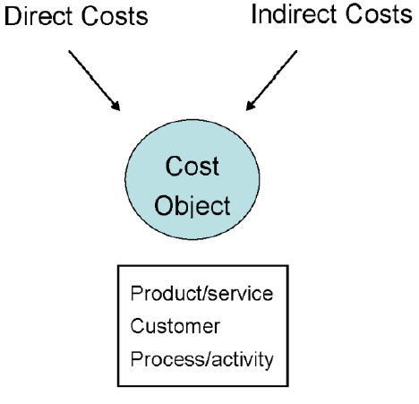

Process Costings
Martin used the idea of making chocolate to define process costings. But perhaps I can relate it to my own business. Within my company we make boxes to put horticultural produce in. Inside this business there are clearly identifiable “processes” in which we can associate costs to. So, in the manufacturing of a box we can allocate the cost of labor, glue, paper, shrink wrap and strapping. This enables us to associate the cost of the items to the process of making the box. This also in turn enables us to clearly identify the individual cost of a single unit. From there we can identify the price we need to sell that unit for.
This is also valuable for operational management, because we can clearly identify how much labor cost it takes to produce 1000 boxes. From there I can work out production efficiencies, machine speeds and a variety of other operational metrics that enable a business to run more effectively.
Furthermore, we can see how indirect costs play a role here. The site I run this manufacturing at requires a monthly lease payment, electricity, gardening and many other items. All of these equate to indirect costs. They are bundled together in the operational expense of the business, but I do not attribute these costs when working out the direct cost a particular box costs to make.

Product and period costs
Martin describes the product costs and finished good inventories or in my business shortened to FIG. FIG can be a major issue within a business because we incur a cost to produce FIG that is it is an expense until able to be sold. However, we allocate the FIG as an asset because it provides “future value” because we expect to sell it at some stage.
FIG is a constant juggling act, because various departments within a business have different agendas when it comes to FIG. Because goods cost the business to make we generally like to see a reasonable turn around on it. That is to say we don’t like to have something that cost the business money to make just sitting there. Business generally want to see a return on this investment. However how quickly can often be an issue. This can be displayed through the understanding of two different business models.
McDonalds vs Bunnings.
Bunnings works on a more wholesale model whereby they are committed to hold stock (asset until sold) for a significant period of time until someone needs it. They provide a long-term view where items may sit on their shelves for months until sold. Generally, these businesses will look to devalue this asset after a period (say 12 months) and as such items may go on sale in order to encourage a consumer to exchange currency for the asset.
McDonalds on the other hand does not hold FIG. They hold a minimal amount of product to enable them to create FIG but expect the FIG to rapidly turn over and create income almost immediate. The ability to measure economic performance over a variety of timelines enables business to better view their economic realities.

Indirect costs
It’s all the same bucket of money, right? I often say this to my national manager when we need to find money for a particular expense. Martin discusses the indirect overheads of a company are “apportioned” across an enterprise to ensure everyone is accountable to their share. I always find it interestingly as to how far a company goes with this.
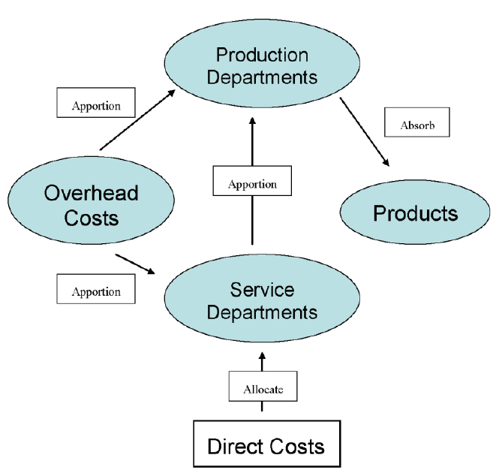

Do companies like Cadbury allocate a certain amount of toilet paper to each floor of their building? Probably not, however they would attribute the costs of their commercial in-house cleaning to each department in order to spread to load. You then need to absorb these costs into your products in order to ensure you can afford them As described in the functional based costing systems and the graphic below.
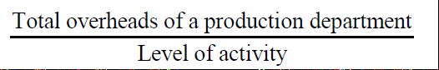

Depending on where you sit in the business chain you often don’t see this level of detail. In fact, it’s even hard to imagine allocating a proportion of electricity to a product. The reality is many companies would work out an indirect cost price per unit, that is to say they would take all the indirect costs and bundle them up across the various functions and then “guestimate” how much they can attribute. For my business it may be something as simple as 1 cent per unit produce covers indirect costs for the year this would be more along the lines of a predetermined overhead absorption rate.

How costs change…
Pursuing business opportunities can be a fickle game. Martin discusses how managers chose opportunities based on variety of data. Forecasting sales is often a reasonable measure in order to try and discover if something is worth pursing especially if capital investment is needed in order to fulfill it.
I often do a simplified cost benefit analysis, that’s is look at what something will cost to pursue vs the expected forecast benefit from that pursuit.
In my company we have recently purchase a new piece of machinery that will provide boxes to my customers. We did this based off the fact we intended to sell a new style of box for a fixed price to a key and existing customer. The initial fixed cost of the equipment was significant although as we drilled deeper we found that it provided a plethora of benefits which included:
- Better efficiencies for the boxes we were already making – this in turn reduced some of our variable costs such as labor, glue, waste.
- The ability to provide new styles to market – this would be a variable until we gained commitment from customers, although I often say you can’t sell what you can’t make.
- Reductions in electricity and forklift usage due to the speed of the machine vs what we were already using.

Cost Volume-Profit Analysis
Martin describes how costs are relatable to levels of activity. As described above the costs of production will reduce with our new machine because our activity will decrease due to better efficiencies. An equation that describes this is:
Y=f(x)
Martin also describes “breakeven”. Being a point in a firm’s operation where they make enough revenue to pay for the costs of operating. Anything past this point is deemed profit. This is often built into the unit price of something, therefore companies can look to improve efficiency or reduce costs in order to gain a greater gross margin. For my business I might work on a break even amount of 20 cents per unit. After every production run I calculate the total cost of each unit produced and look to see if I am over or under the b/e figure. I can then ensure I am operating within the realities of my costs.
Overall this has been a really enjoyable chapter. I think it is due to the fact that many of the concepts are relatable to my own business and in-turn become easily identifiable with the reading.

